**Fall 2019**

**CSE-5321-002 - Software Testing**

**Homework Assignment 4**

|  |  |
| --- | --- |
| **Name** | **UTA ID** |
| Goutami Padmanabhan | 1001669338 |

Please find the CSV files I used for testing (/CsvTestCaseTables) and Junit test files (/JUnit Test Files), attached to the zip file I submitted.

**Problem 1**

**1.Test Case Table:**

|  |  |  |  |  |  |  |  |
| --- | --- | --- | --- | --- | --- | --- | --- |
| **Test Case Number** | **Inputs** | **Expected Outputs** | | | | | **Basis Path** |
| **batteryPower (watts)** | **red** | **yellow** | **green** | **bell** | **siren** |
| 1 | 0.0 | FALSE | FALSE | FALSE | FALSE | **TRUE** | 15-16-32 |
| 2 | 49.9 | FALSE | FALSE | FALSE | **TRUE** | FALSE | 15-18-19-32 |
| 3 | 75.0 | **TRUE** | FALSE | FALSE | FALSE | FALSE | 15-18-21-22-32 |
| 4 | 124.9 | **TRUE** | **TRUE** | FALSE | FALSE | FALSE | 15-18-21-24-25-32 |
| 5 | 250.0 | FALSE | **TRUE** | FALSE | FALSE | FALSE | 15-18-21-24-27-28-32 |
| 6 | 250.1 | FALSE | FALSE | **TRUE** | FALSE | FALSE | 15-18-21-24-**27-30-32** |
| 7 | 0.1 | FALSE | FALSE | FALSE | **TRUE** | FALSE | - |
| 8 | 50.0 | **TRUE** | FALSE | FALSE | FALSE | FALSE | - |
| 9 | 75.1 | **TRUE** | **TRUE** | FALSE | FALSE | FALSE | - |
| 10 | 125.0 | FALSE | **TRUE** | FALSE | FALSE | FALSE | - |
| 11 | 1,000.0 | FALSE | FALSE | **TRUE** | FALSE | FALSE | - |

**2.Junit Pass Indicator:**

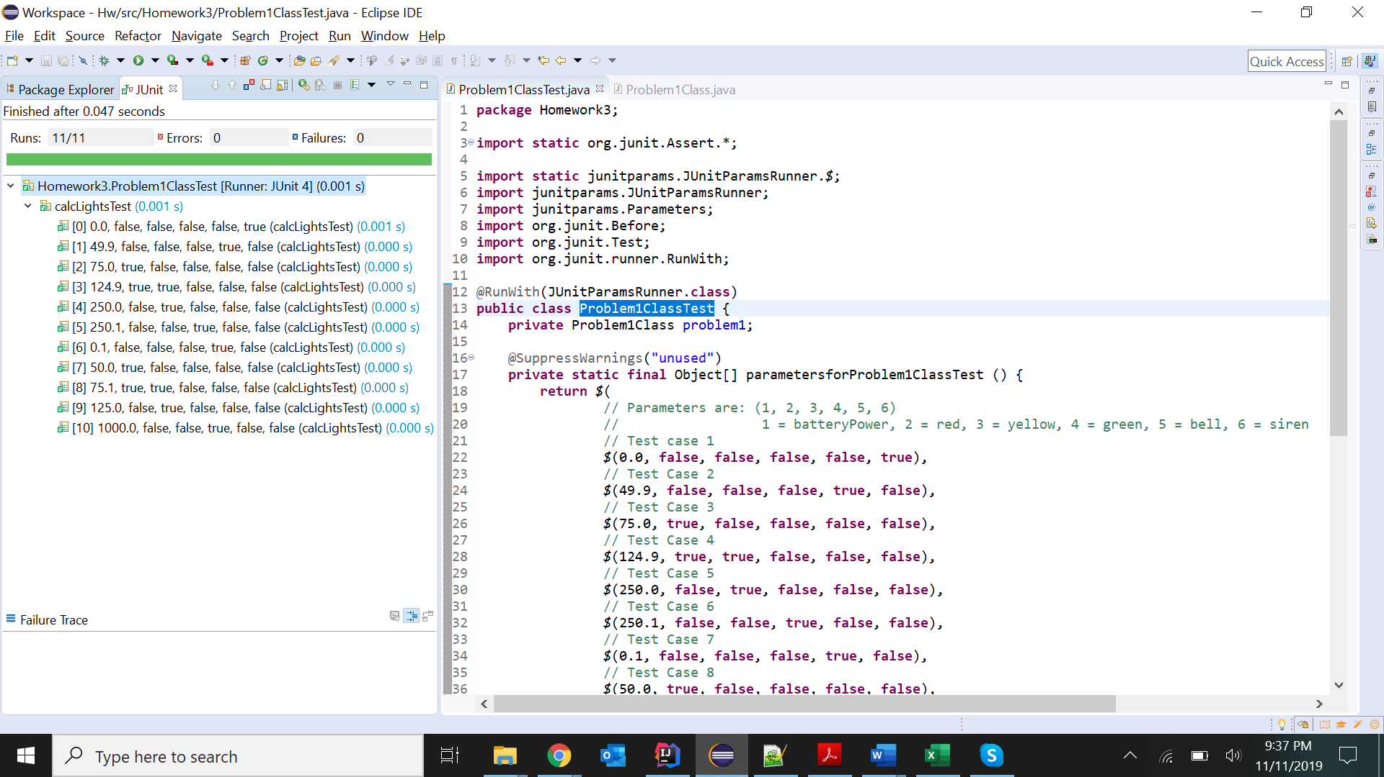

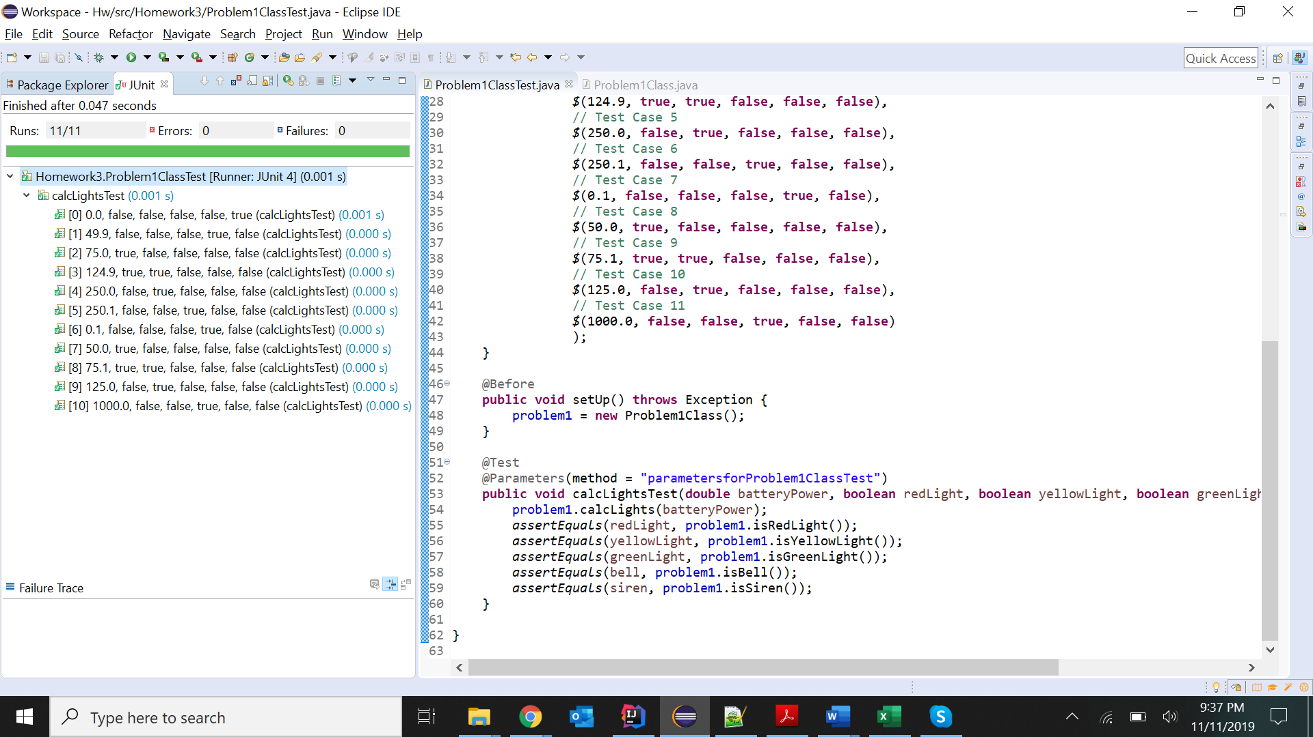

**3. JaCoCo Statement Coverage:**

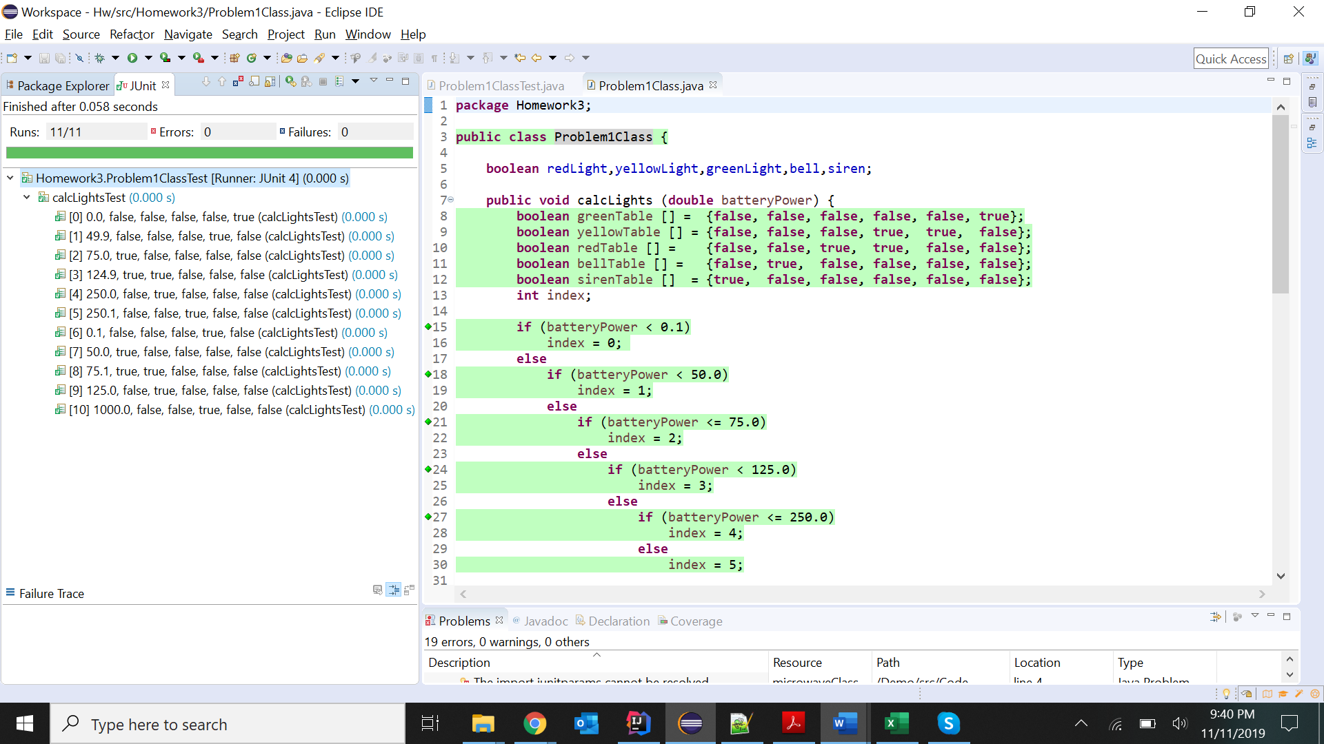

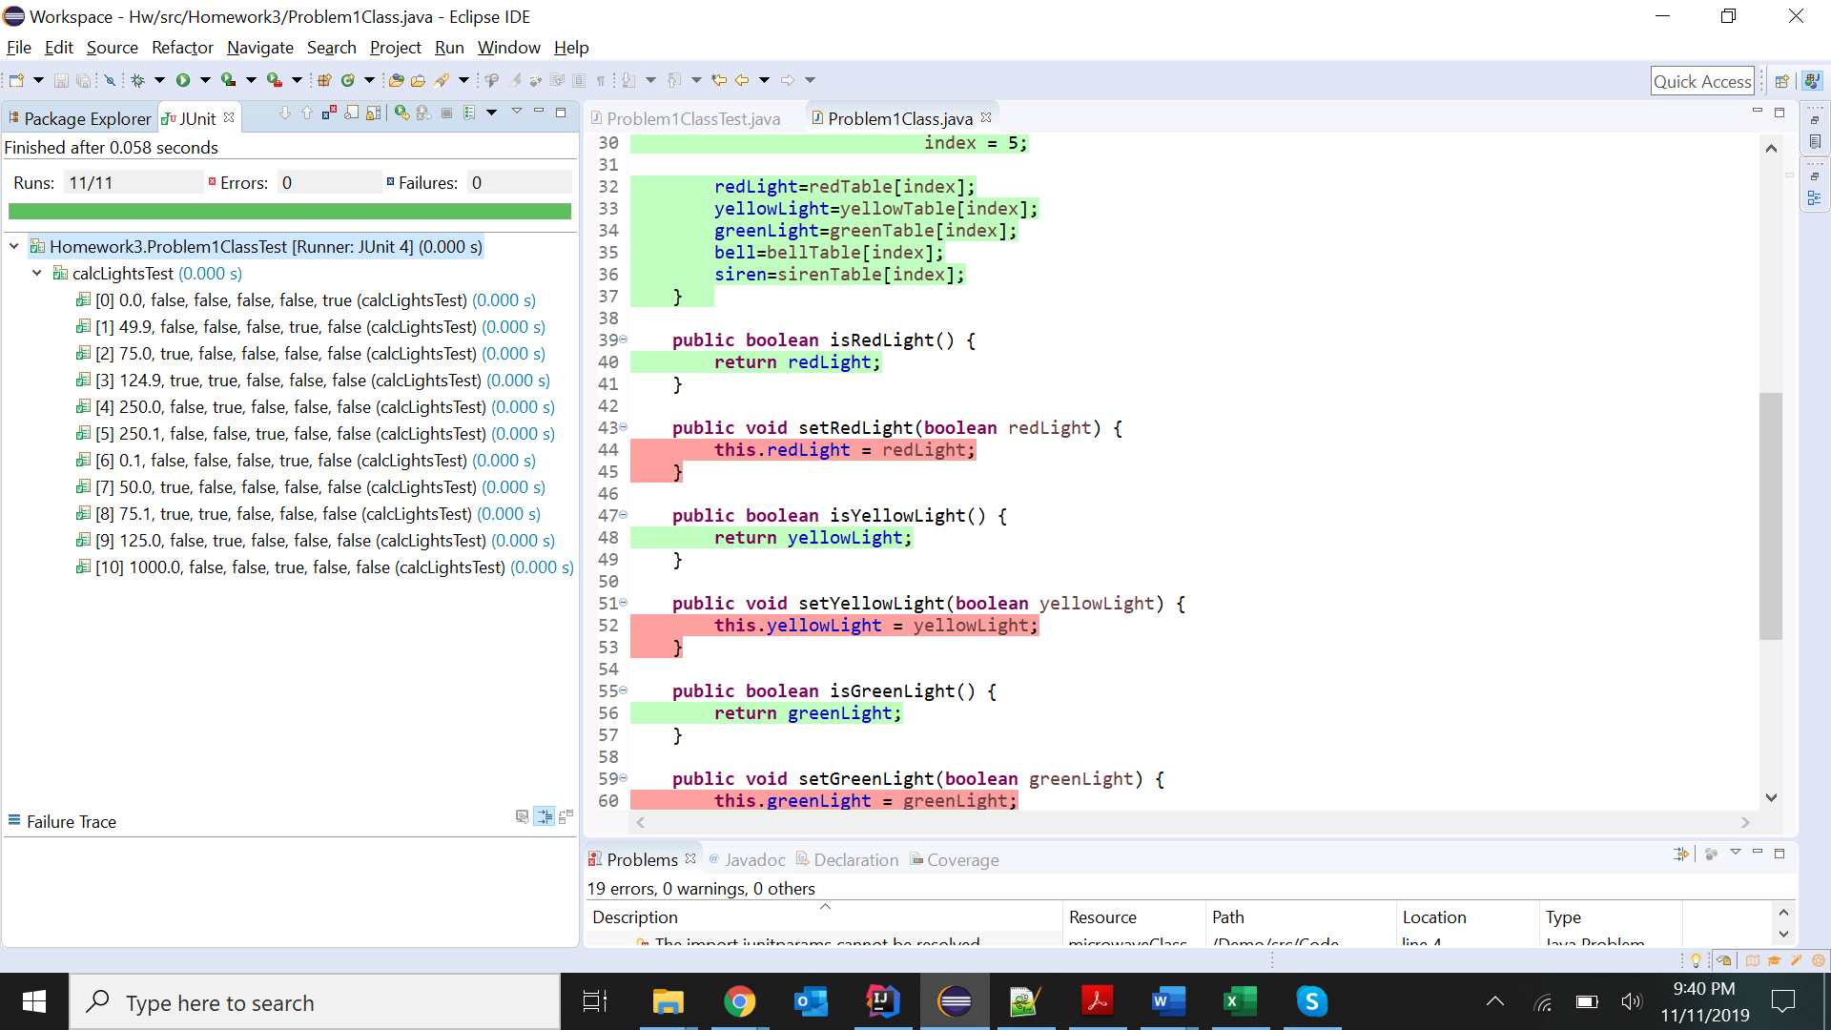

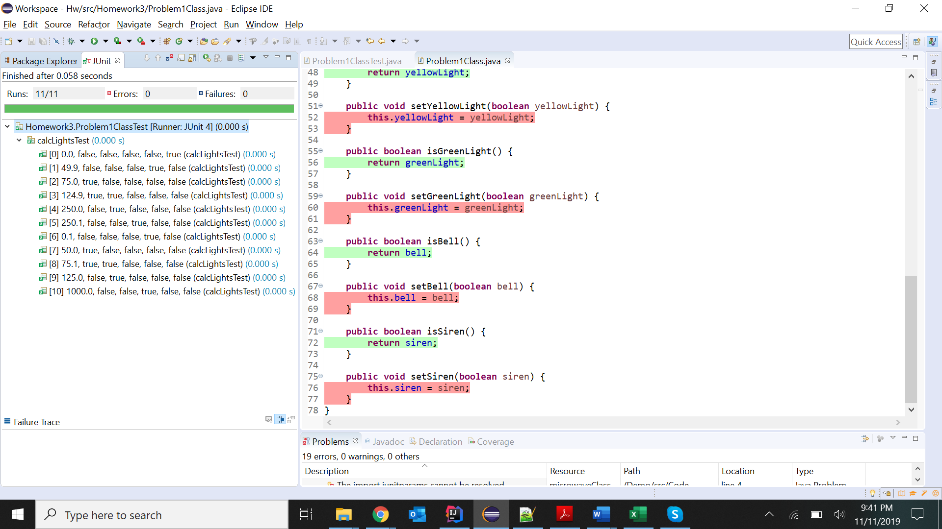

**Problem 2**

**1.Test Case Table:**

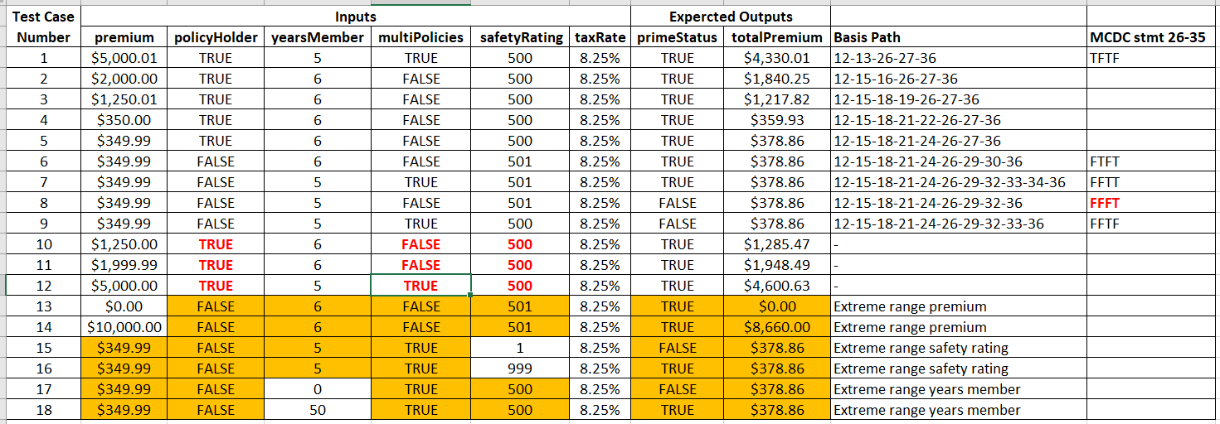

**2.Junit Pass Indicator:**

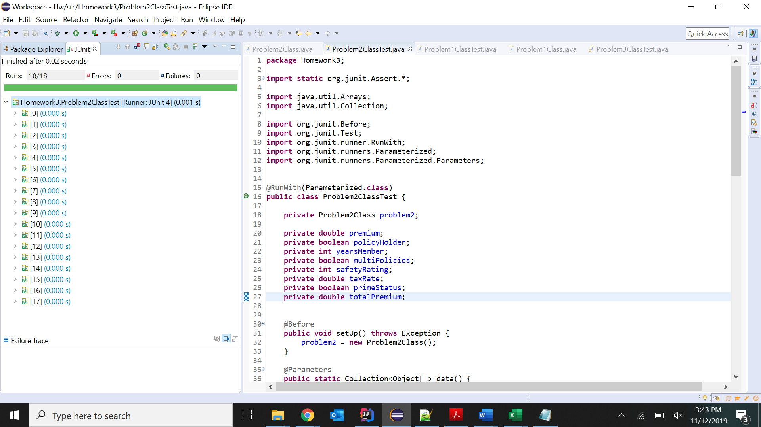

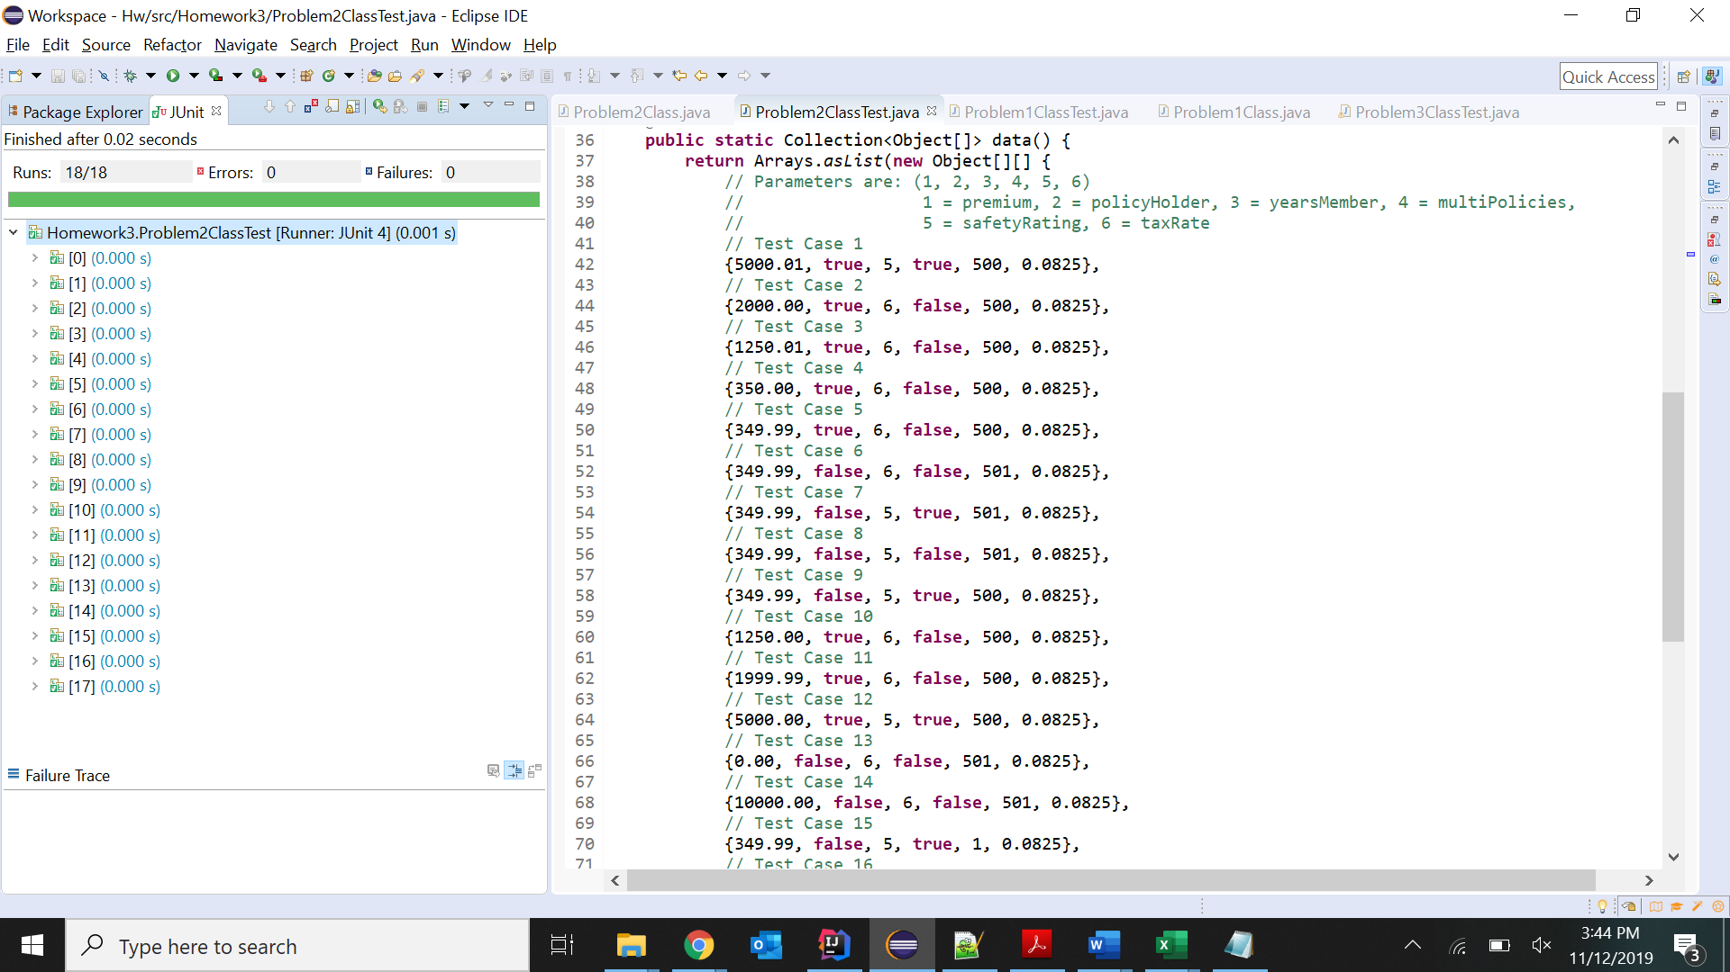

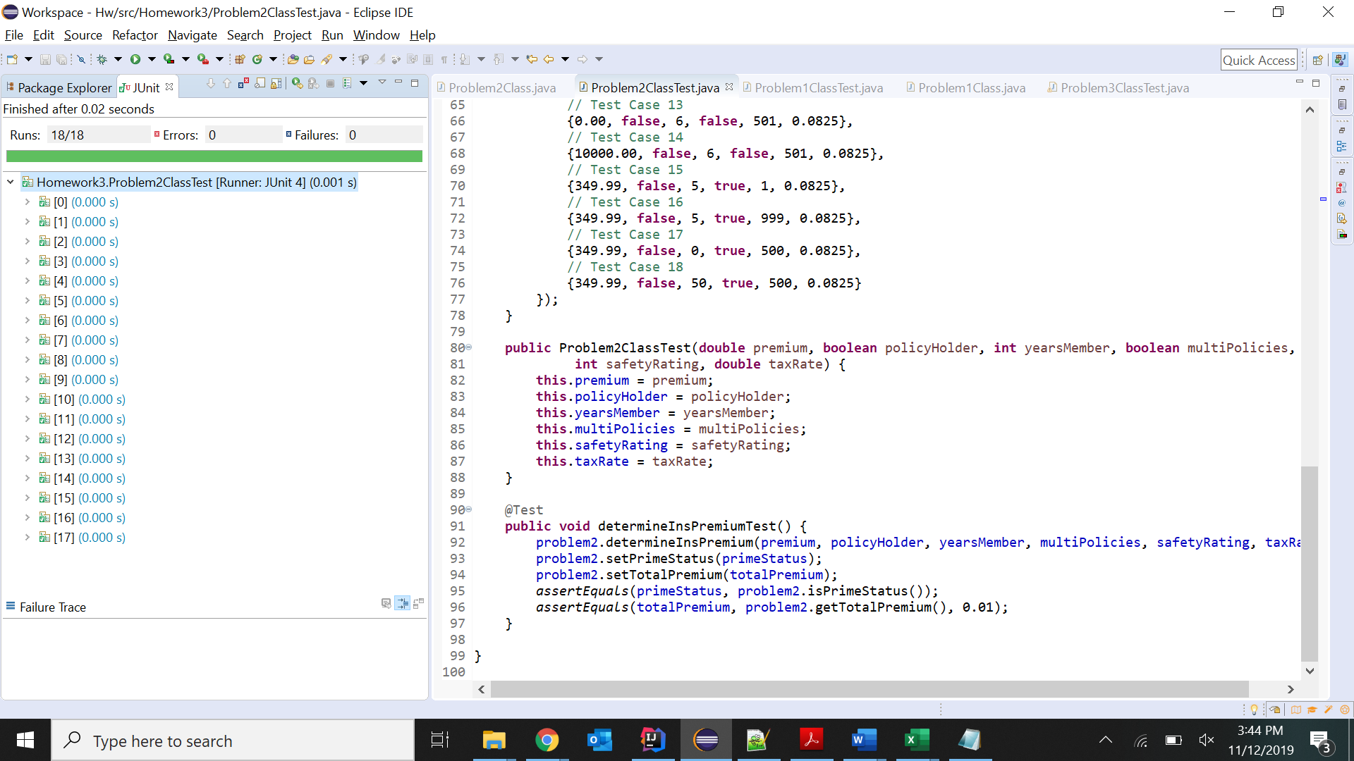

**3. JaCoCo Statement Coverage:**

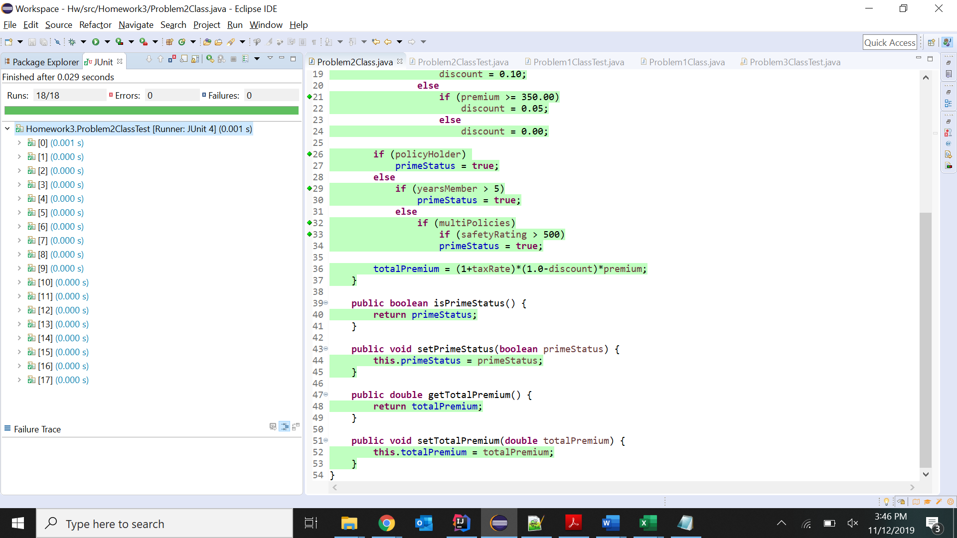

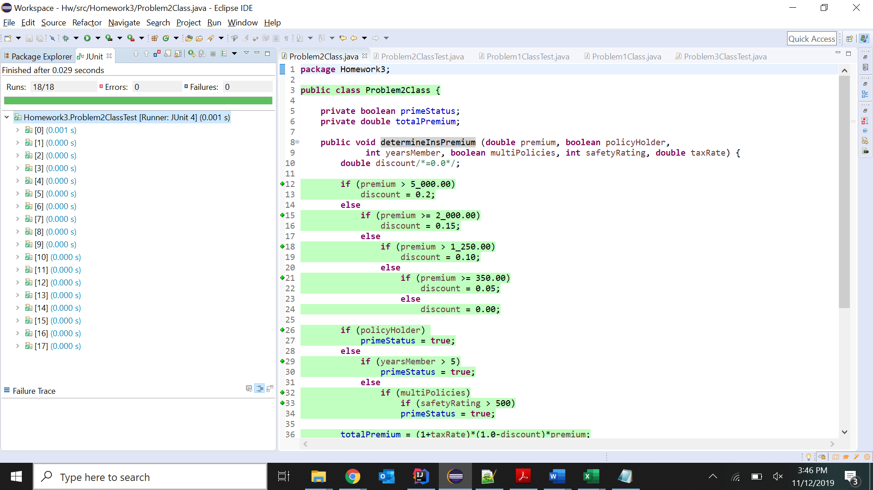

**Problem 3**

**1.Test Case Table:**

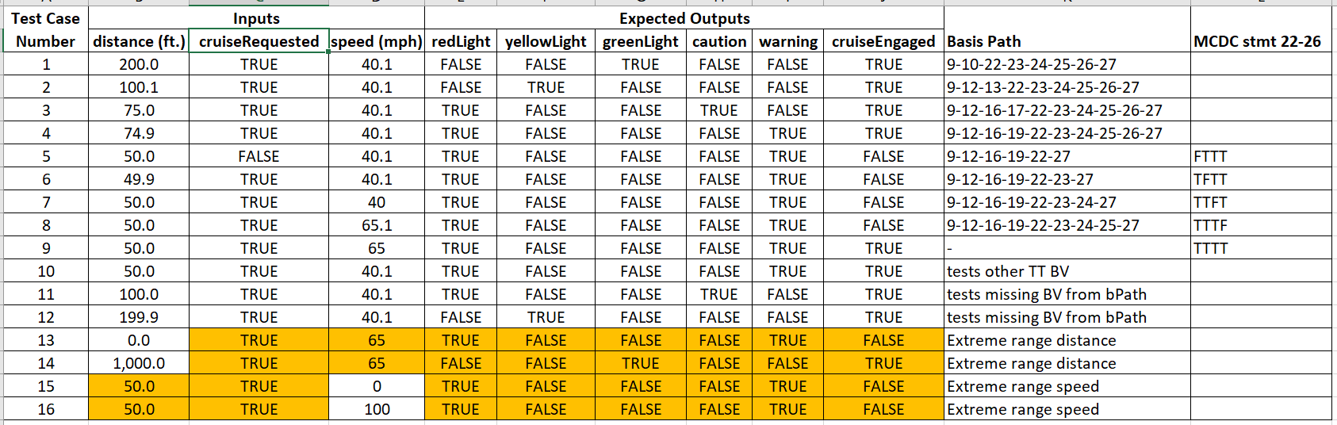

**2.Junit Pass Indicator:**

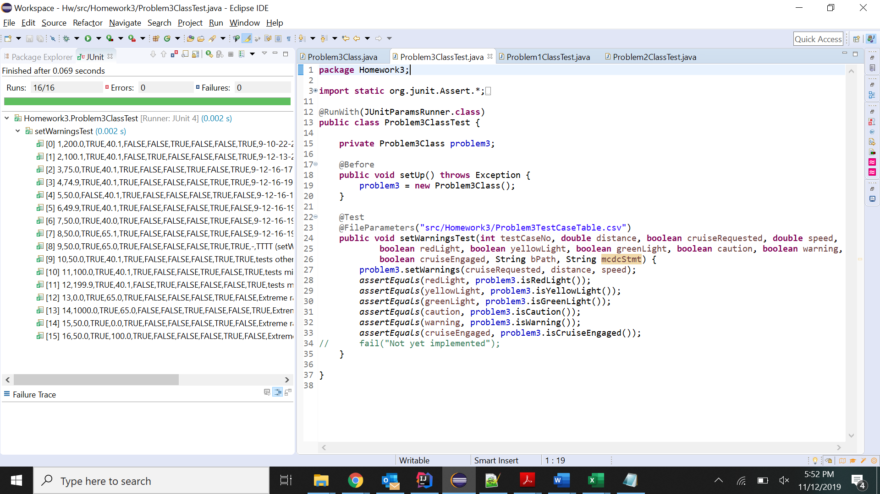

**3. JaCoCo Statement Coverage:**

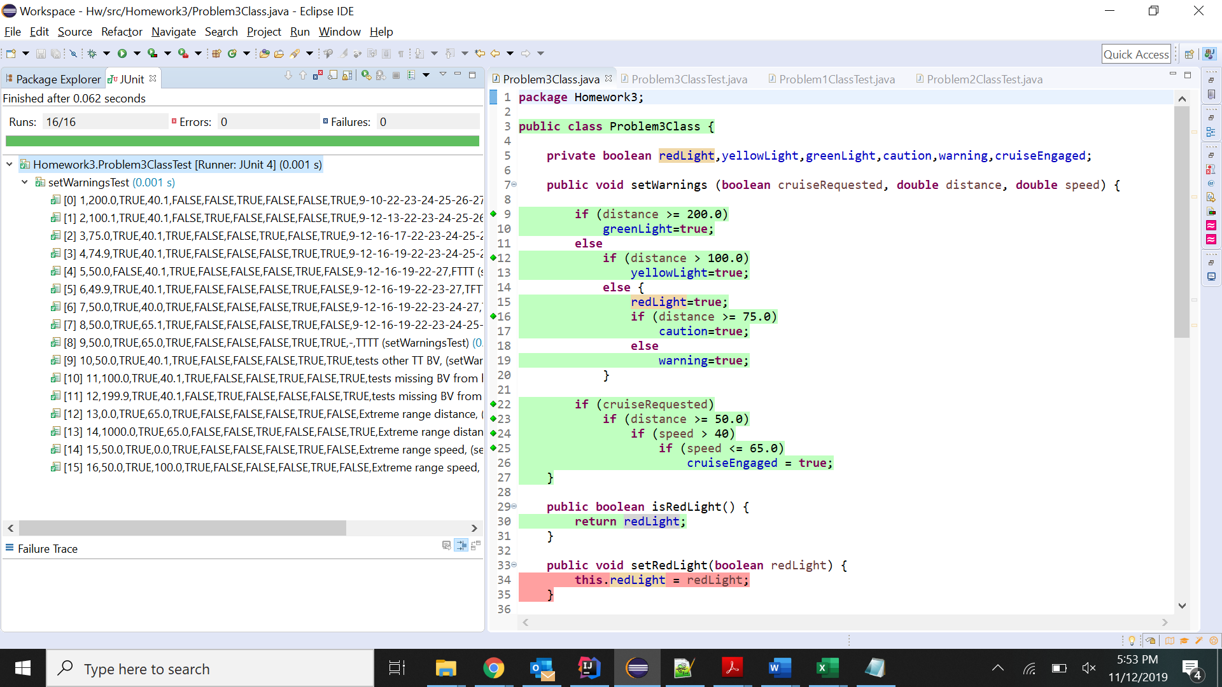

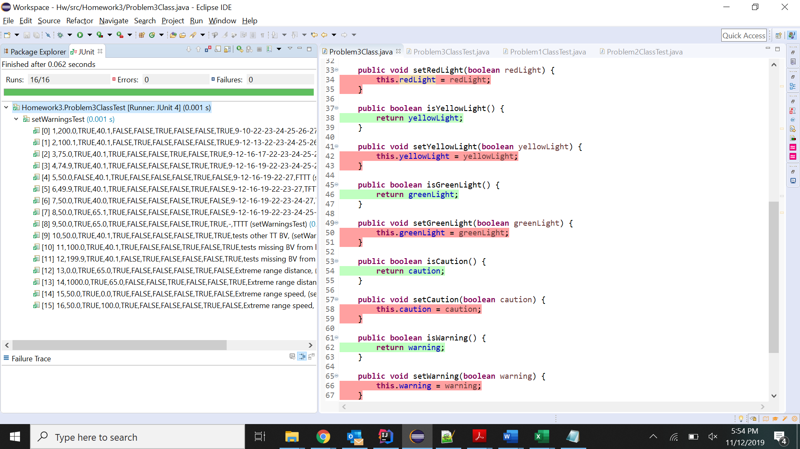

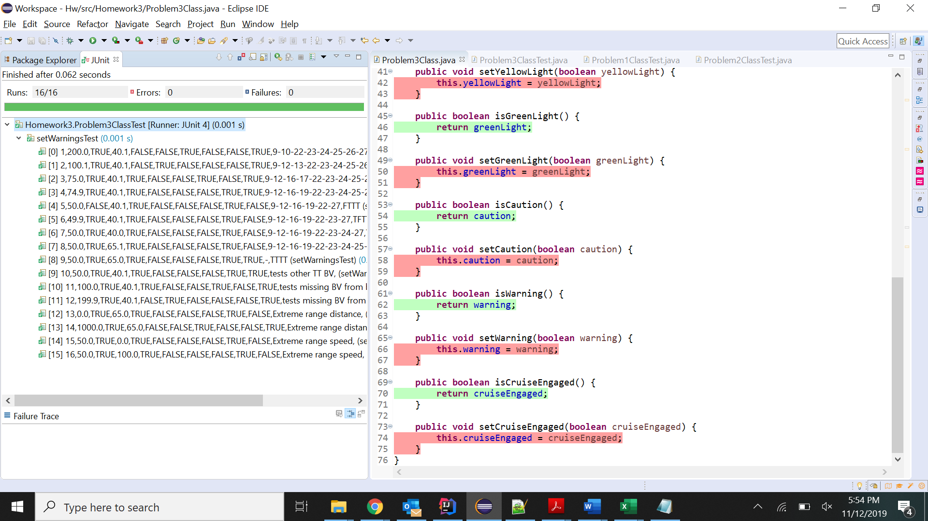

**Problem 4**

**1.Test Case Table:**

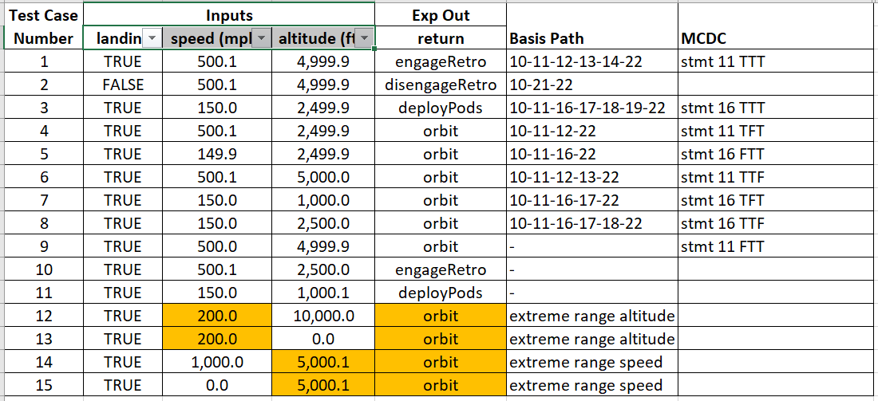

**2.Junit Pass Indicator:**

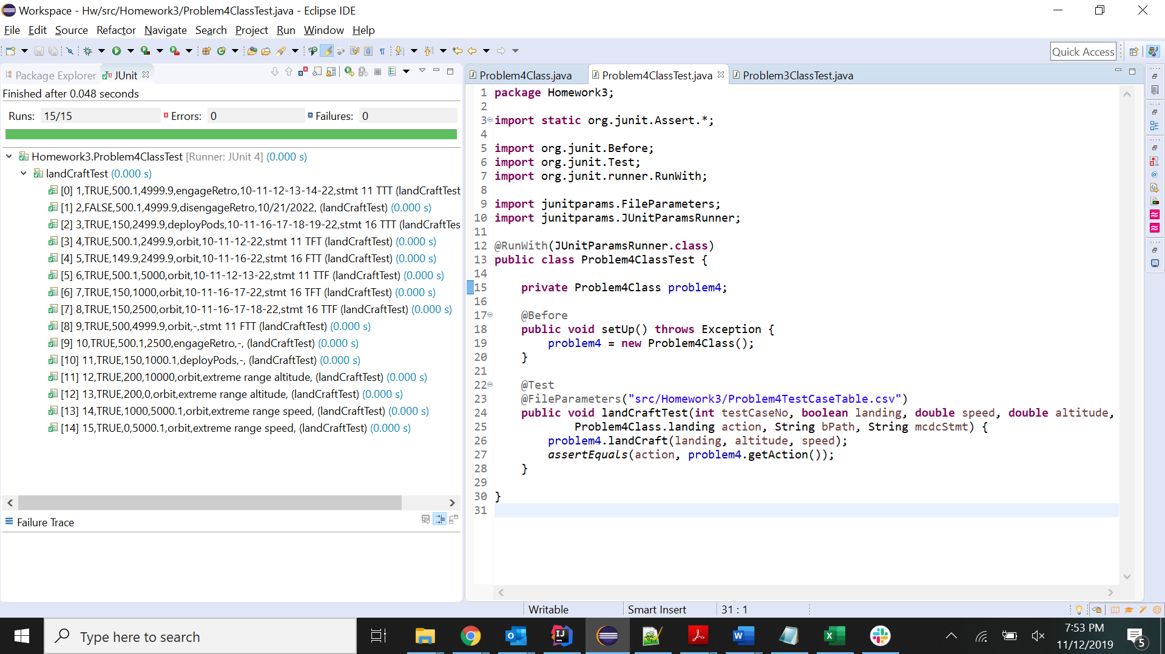

**3. JaCoCo Statement Coverage:**

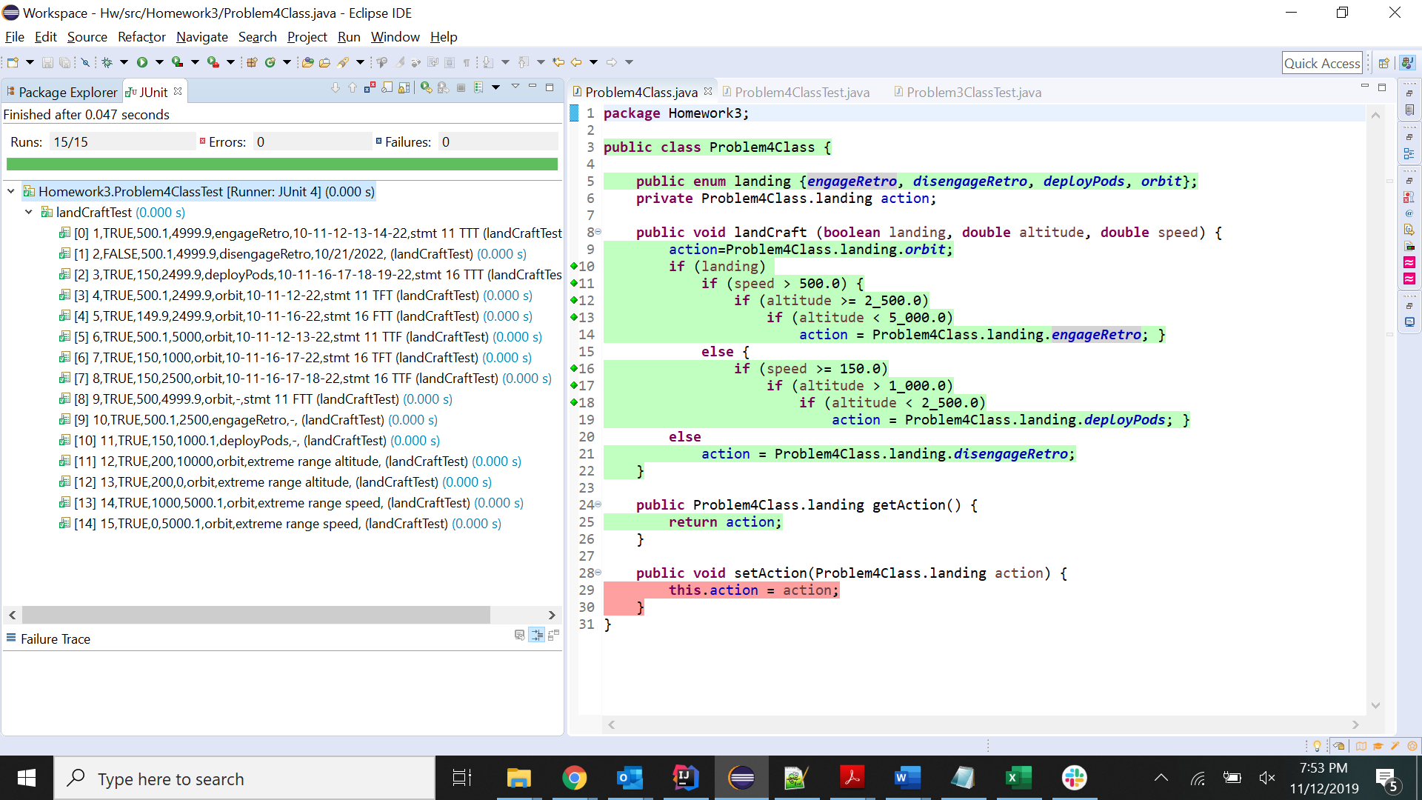

**Problem 5**

**1.Test Case Table:**

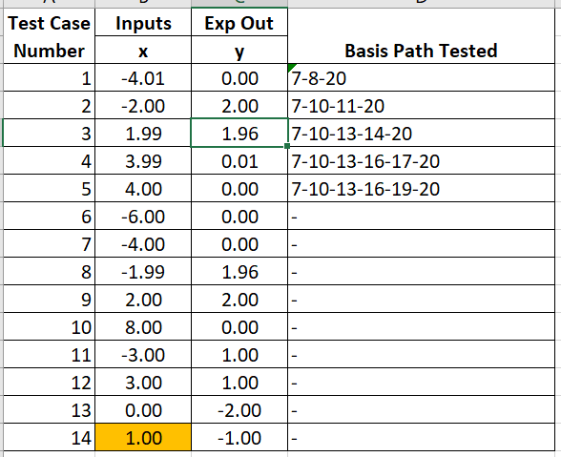

**2.Junit Pass Indicator:**

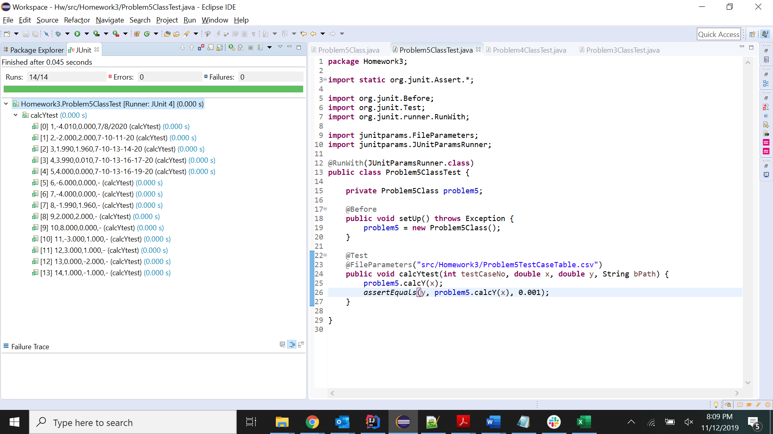

**3. JaCoCo Statement Coverage:**

